Professional Development: Wiki, Part I (create & personalize)

Presenter: Denny Dupps, Technology Resource, CEEMS Grant, UC
Date: Wednesday, June 22, 2016
Time: 2:45-4 PM
Venue: University of Cincinnati, Zimmer Hall, Room 414

Prepared by:
John J. D’Alessandro, St. Xavier High School, Cincinnati, OH
RET Participant for Project #2: “Synthesis Characterization of Graphene for Energy Storage Devices”

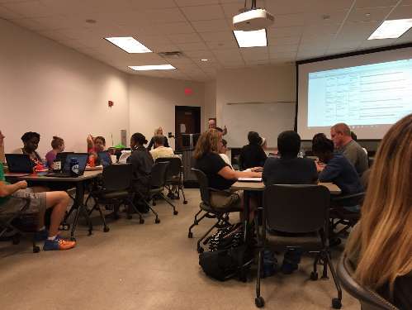
Dennis “Denny” Dupps, the presenter, currently serves as the Technology Resource person for the CEEMS grant at UC. He earned BS in Industrial Arts Education at Morehead State University and a Masters in Secondary Education from UC, as well as, additional coursework in Information Technology, Computer Science, Digital Video Productions and Robotics. He has been a high school technology teacher at Indian Hill High School for the past 45 years. He served as the President of the Ohio Technology Education Association from 1984-86. He continues to teach part time at Indian Hill High School and is the faculty advisor of the Indian Hill Television Network which produces a weekly news program and many sports and musical programs throughout the district.
Figure 1. Participants Working on Modifying Wikis
Ms. Debbie Liberi introduced the presenter, “Denny” Dupps. Mr. Dupps explained his role in the CEEMS program as a guide and assistant. The topic was about creating individual Wiki’s to present CEEMS and RET Units to the world. Mr. Dupps attempted to get the last of the participants to submit links to their Wiki’s.

The Objectives were listed as getting the Wiki posted and sharing for the correct people to have the correct permissions. These are listed on the posted PowerPoint on the CEEMS Wiki, https://sites.google.com/site/ceemssummer2016/home/workshops/wiki-workshop-2015. Participants will also be able to upload documents and use Wiki tools for maintenance and management.
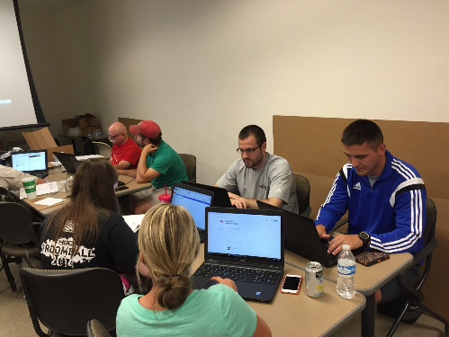
Mr. Dupps pointed out that when viewing documents on the participants’ pages, if the viewer clicks the “X” next to the document, it will delete the document and the document will have to be re-uploaded. Mr. Dupps pointed out that he is a “stalker,” since he subscribes to participants Wiki pages and receives announcements every time the participants update anything on their Wiki pages.
Figure 2. Particpants Making Wikis Look Better
The participants practiced changing aesthetic settings of their sites. They learned how to delete and copy their whole Wiki site.
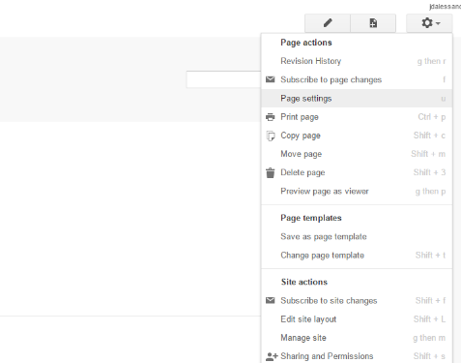
Mr. Dupps also showed how to access Help on the site. The Wiki of a participant was brought up as an example of having a school schedule. Her schedule was shown on the presentation screen. Another’s school calendar was also shown.
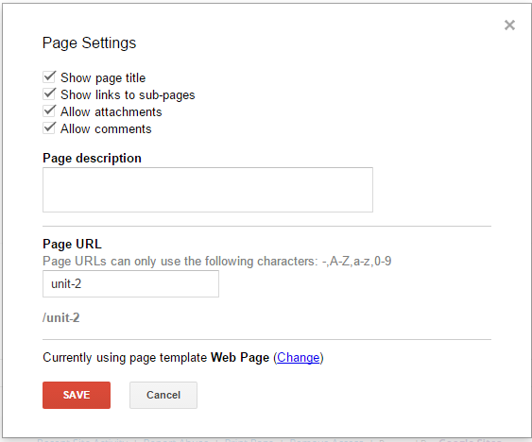
A participant asked about posting a Google Docs document. Mr. Dupps pointed out that was a good question and reminded participants that they need to keep the templates in Word documents. He showed how participants can change the format of a Wiki page (using that page’s settings) from “web page” to “file cabinet.” Mr. Dupps then proceeded to show how to insert video from YouTube.com. Participants were instructed to place their videos in the correct place on their Unit pages. He also demonstrated that one may modify location of items placed in a “web page” and then turn the page back into “file cabinet” so that both the web elements and the files are places on the page.
Figure 3. Select "Page Settings" to Access Page Template Types
Mr. Dupps repeatedly asked if there were questions and complimented the participants on how far they were compared to other cohorts at that time. The participants were dismissed at that point.
Figure 4. Change Page Template Type by Clicking "Change"

